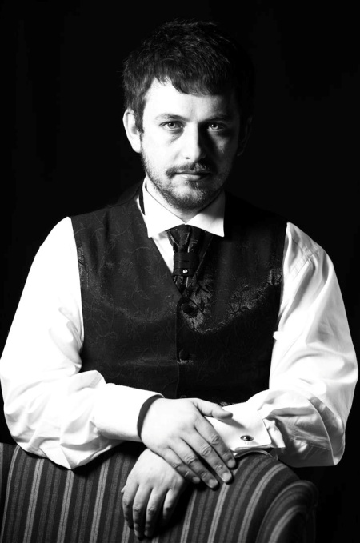**AGRON SHUJAKU-** took his first music lessons, respectively on piano when he was 10 in the class of Letafete Ballata. Back then, he participated intensively in many concerts in Prishtina and Prizren. He also performed in “The Days of Music Schools in former Yugoslavia” in Slovenia (Vrhnika) and Serbia (Belgrade). The music school awarded him a diploma of gratitude for his engagement and participation in many concerts (1989). He began his high school in the class of Prof. Dragoljub Apostolov (1990)and he continued with piano studies in the class of Prof. Lejla Pula - Haxhiu until his graduation in University of Prishtina (1997). During his studies, he performed in many events organised by the Faculty of Arts.He also took part in concerts organised by “Artists’ Association”. The University of Prishtina awarded him the “Distinguished Student” Diploma for his achievements during his studies. He also engaged in re-activating the Octet directed by Prof. Rafet Rudi (1994). After this period, he was involved in piano teaching for 20 years as professor of piano in high school of music “Prenk Jakova” in Prishtina. He gave pedagogical contribution to the University of Prishtina where he has been engaged for several years, and recently was appointed as a pianist-collaborator. Most of his students are distinguished pianists in Kosovo. Besides teaching piano, his activities include: 4 solo concerts, various concert activities with chamber groups in the capacity of co-repetition (piano accompanist), participation in festivals like: “Bach Week”, “Chamber Music Festival”, “Remusica”, “Tingujt e Flautit”, “Dam Festival”, “Arskosova” where he performed with numerous Kosovar and foreign artists. He also composed film music: “Mesazhi” (2009) and “Vula e fatit” (2004).. He took part in the annual symposium “Golandsky Institute” in 2008, where he had the opportunity to closely familiarize with Taubman technique. He was a jury member in the Internacional Competition organized by “Arskosova” association (2010,2011). In year 2011 he finished master Studies in “Sv.Kirilj i Metodij” university in Skopje, in the class of Prof. Todor Svetijev and gained the title “Magister of Piano” . He is actively engaged in concerts through Kosovo and recently organized presentation and masterclass tour in Kosovo cities (2015) where he presented and demonstrated Taubman Method of achieving piano technique. For the first time in Kosovo he has introduced Taubman's piano technique through master classes and presentations in major Kosovo cities (December 2015). Also in cooperation with CultureForAll has expanded the next project in all cities of Kosovo (June, 2016). In February 2017, this project was transformed into a multi-day workshop that was realized through the support of the Municipality of Prishtina. In 2012 he was selected by Ministry of Education of Kosovo as a beneficiary of the Scholarship for Postgraduate Studies at the University of Sheffield - City College in the Master of Business Administration (Executive MBA) which he successfully completed in 2017. From the year 2015, he is Manager of the "Young Pianist" competition – annual traditionally held competition for young pianists in Kosovo (2015-2019)..In addition to the numerous activities of pianist accompaniment, since 2018, he is also pianist of the choir "Siparantum", a young choir who is reaping numerous successes on the Kosovar scene and successful appearances on the international stage (France, Croatia, Italy, Macedonia, Albania) .