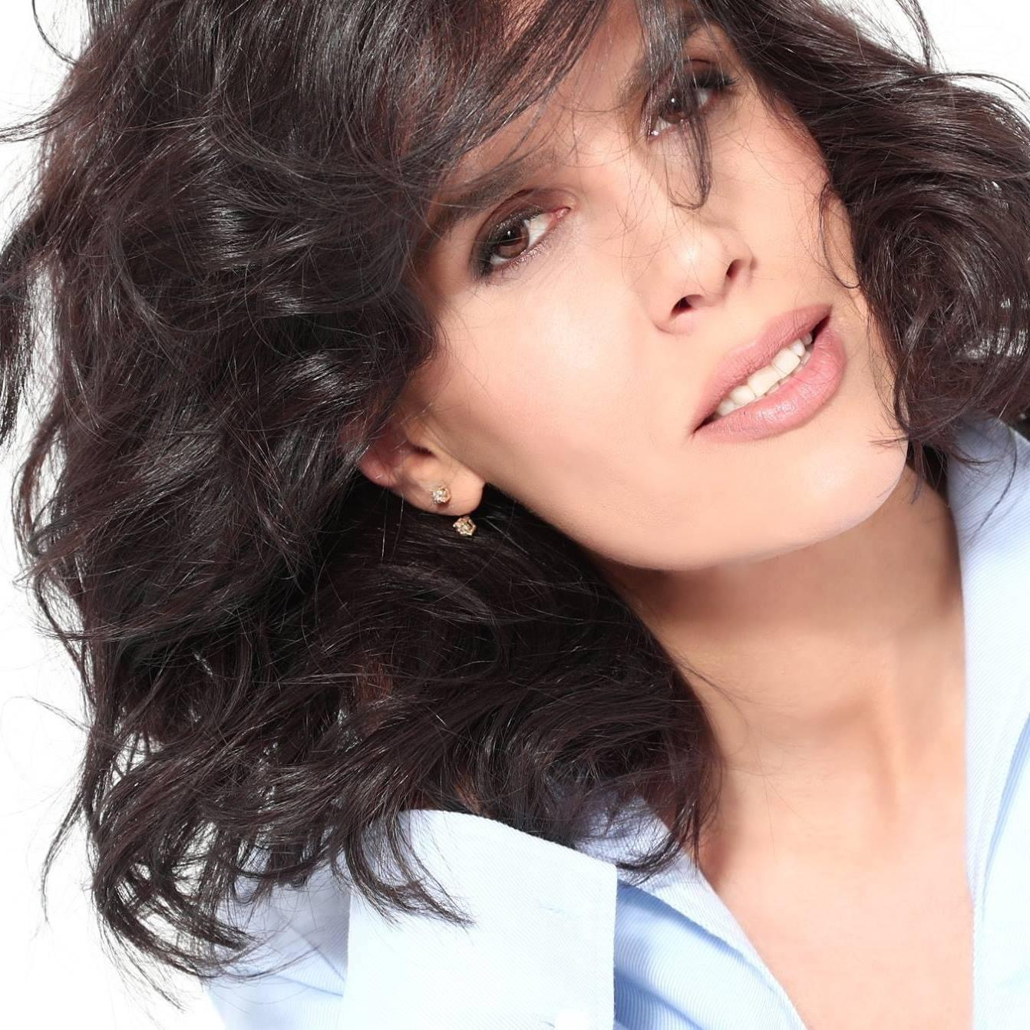Sanije Matoshi  Mezzo-soprano  EXPERIENCE  University of Prishtina, Prishtina, Kosovo—Assistant Professor  2016 - PRESENT  Lecturer of “Solo Singing” in the Faculty of Fine Arts in the University of Prishtina  University of Prishtina, Prishtina, Kosovo —Assistant Professor  October 2010 -  Lecturer of “Solo Singing” in the Faculty of Fine Arts in the University of Prishtina  Kosovo Philharmonic, Prishtina, Kosovo— Solo and group singer  2007 - 2010  NOVAT – Novosibirsk State Academic Theater of Opera and Ballet, Novosibirsk, Russia - Solo Singer  2004-2006  Kosovo Philharmonic, Prishtina, Kosovo— Solo and group singer  2003 - 2004  Nation Ensemble of Song and Dance , Prishtina, Kosovo— Solo singer  2000 - 2004 | Nr. 12 Mujo Ulcinaku  Prishtina , 10000  +393 44 740 338  s_matoshi@hotmail.com  SKILLS  - Microsoft Office  - Google Suite  - Skype, Zoom, Google Meet.  AWARDS  2018 - Certificate from the City  Council of New York  2000-2014 - Awarded several  certificates for performing on  concerts of classical Music  1993-1998 - First place award  winner in several national  competitions of Albanian artistic song  1997 - Awarded “Academic Excellence” Certificate by the University of Prishtina  LANGUAGES  Albanian  English  Russian

EDUCATION

Sofia, Bulgaria — Master class for Opera Singing

- 2015
Lectured by Russian Soprano Larissa Gergiev

New Bulgarian University, Sofia, Bulgaria — PhD of Opera Singing

2014
PhD thesis topic: “The development of Italian and French Music from the time of Baroch until the 21st century”

Arts Academy of the University of Split, Split, Croatia— Master class of Piano Project for Opera Singing

2013

MUK - Music and Arts Private University of Vienna, Vienna, Austria— Master class for Opera Singing

16-28, July, 2012
Lectured by Prof:Eva Blahova

University of Prishtina, Prishtina, Kosovo— MFA in Solo Singing

October 2008
In the Faculty of Fine Arts of the University of Prishtina with the Master thesis: “ G.Verdi – “Il Trovatore', 'H. Purcel -Dido and Aenea”

Vadstena Akademi, Stockholm, Sweden— Master Class

2002

International Summer Academy of Fine Arts in Salzburg, Salzburg, Austria — Master Class

2000
Lectured by Prof. Ortiz Arandez

Mozarteum University Salzburg, Salzburg, Austria— Master Class for Opera Singing

1999-2000
Lectured by Prof H.Branisteanu

University of Prishtina, Prishtina, Kosovo — Bachelors of Fine Arts in Solo Singing

1994-1998

Music High School “Prenk Jakova”, Prishtina, Kosovo— High School Diploma

1994

International Performances

Concert - ‘’Poetica Musica’ — May, 2018 - Old Westbury Gardens, New York
Accompanied by Soprano Ellie Valkenburg and Guitarist Oren Fader

Concert - ‘’Belcanto Dolcinio' —May, 2018 - Symphony Space, Broadway New York
Organized by the Albanian-American Foundation.

Concert — AAB college, -- October, 2017 - Prishtina
Concert held during the “Movie week”

Concert - ‘‘’Belcanto Dolcinio’’’ — September, 2017 Ulcinj, Montenegro
Two concert nights organized by the Albanian-American Foundation

Concert —February, 2017 , Zürich, Switzerland
Accompanied by Ermira Lefort in Piano Organized by the Ministry of Diaspora of Kosovo for the Independence Day of Kosovo.

Concert — December, 2016, New York
Organized by the Embassy of Kosovo in New York.

Humanitarian Concert — April, 2016, Prishtina.

Concert - March, 2016— Accompanied by Ashot Khachatourian in Piano

Concert with ‘’Rexho Mulliqi’’ Orchestra —December, 2015 , Gjilan, Kosovo.

Concert with ‘’Rexho Mulliqi’’ Orchestra —December, 2015 , Gjakove, Kosovo.

Concert in “Prenk Jakova” —December, 2015 , Gjakova, Kosovo.

Concert — November, 2015, Switzerland
Albanian Culture Week in Switzerland.

PhD Concert in “New Bulgarian University” —June, 2015, Sofia, Bulgaria

Concert in Museum Boris Christof — November, 2015. Sofia, Bulgaria.

Concert — November, 2015 - Sofia, Bulgaria
As part of the Master Class with Larissa Gergiev

Concert with ‘’Rexho Mulliqi’’ Orchestra— February, 2015 - Prizren, Kosovo.

Concert with ‘’Rexho Mulliqi’’ Orchestra— February, 2015 - Tetove, North Macedonia

Concert with ‘’Rexho Mulliqi’’ Orchestra— December, 2014 - Prishtina, Kosovo.

Concert -Academy of Arts — December, 2014 - Prishtina

Concert - Academy of Arts of Tirana— November, 2014 - Tirana, Albania.
Accompanied by the Philharmonic of Tirana

Concert - 2014 - Ljubljana, Slovenia.

Concert - June- July, 2013 - Split, Croatia.
Aa part of the Master Class -Piano Project

Concert of Kambelovac Castle -July, 2013 - Split, Croatia.

Recital Concert - 2013 - Prishtina, Kosovo.
Organized by the Rector of the University of Prishtina.

Concert - April, 2013
Aa part of the Master Class with Soprano Dorothy Stone

The Chopin Festival-April, 2013 -
Accompanied by Soprano Dorothy Stone

Concert “Re Musica” Festival -2013
Solo Singing.

Concert with the chorus of the Kosovo Philharmonic - December, 2012
As part of the “The days of Kosovar Music” Festival.

Concert - December, 2012, Prishtina, Kosovo
Organized by the University of Prishtina in honour of the 100th anniversary of the Independence of Albania.

Concert Anton-von-Webern-Platz - July, 2012, Vienna, Austria.
As part of the Master class in Vienna, Austria.

Concert - July, 2012, Vienna, Austria.
As part of the Master class in Vienna, Austria with Eva Blahova

Concert - June, 2012,
in honour of the 100th anniversary of the Independence of Albania. And accompanied by Tenor K.Tusha, M.Qerkezi with the flute and A.Troni with the Piano

Concert - May, 2012, Prishtina, Kosovo.
Solo Singer in the Kosovo Philharmonic

Concert - May, 2012, Prishtina, Kosovo.
Solo singer masterpiece El Amor Brujo’Manuell de falle in the Kosovo Philharmonic as part of the Remusica

Concert - May, 2012, Prishtina, Kosovo.
“Day of Europe”, Solo singer with pianist Alberta Troni Organized by University of Prishtina.

Concert with Kosovo Philharmonic Orchestra- May, 2012, Prishtina, Kosovo.
As part of the ReMusica Festival - Solo Singer of El Amor Brujo' MANUELL DE FALLA

Humanitarian Concert - May, 2012, Prishtina, Kosovo.
For the SOS village of Kosovo.

Concert - 2011.
AS part of the music festival “Kamerfest”

Concert - October, 2011, Vienna, Austria.
Concert held at Börse Palais

Concert -April, 2011, Prishtina, Kosovo.
As part of the Second edition of the “CHOPIN Piano Fest” 2011 accompanied by Alberta Troni in Piano

Concert - February, 2011, Hague, Netherlands.
In honour of the third anniversary of the independence of Kosovo.

Concert - December, 2010, Prishtina, Kosovo.
Traditional concert - “Onufri”

Concert - December, 2010, Skopje, North Macedonia.
Solo singer with the Philharmonic of Kosovo.

Concert - June, 2010, Albania.
In honour of Europe’s day.

Concert - May, 2010, Prishtina, Kosovo.
Solo singer with the Philharmonic of Kosovo.

Concert - December, 2009, Prishtina, Kosovo.
In honour of the inauguration of the CHOPIN Kosovar Association.

Concert - November, 2009, Prishtina, Kosovo.
Solo singer with the Philharmonic of Kosovo.

Concert - October, 2009, Tirana and Durres, Albania.
As part of the “New Albanian Music” festival.

Concert - May-December, 2008, Prishtina, Kosovo.
Solo singer with the Philharmonic of Kosovo.

Concert - May, 2008, Prishtina, Kosovo.
Solo singer in the “Re Musica” Festival

Concert - May, 2010, Prishtina, Kosovo.
Solo singer with the Philharmonic of Kosovo.

Concert - 2007-2008, Prishtina, Kosovo.
Solo singer with the Philharmonic of Kosovo.

Concert, -2004 - Prishtina, Kosovo.
Solo singer with the Philharmonic of Kosovo.

Concert -2003, Prishtina, Kosovo.
Solo singer with the “Dasma Arbereshe” Opera ensemble

Concert with K. Tusha and company - 2002, Tetove. North Macedonia
Solo singer

Concert - 2002, Prishtina, Kosovo.
In the Faculty of Philology hall in honour of presenting the title “Doctor Honoris Causa” to Dr. Bernard Kouchner

Concert - 2002, Prishtina, Kosovo.
Solo singer - Organized by The Austrian Office in Kosovo in the National Theatre

Concert with K. Tusha and company - 2001, Tirana. Albania
Solo singer

Concert - 2001, Munster, Germany.
Solo singer - Accompanied by Kosovar artists

Concert - 2002, Prishtina, Kosovo.
Solo singer in the “Bach’s days” Festival

Concert - 2000, Prishtina, Kosovo.
Solo singer of Z. Ballata works-accompanied by Slovenian performers in performing modern music.

Concert - 2000, Prishtina, Kosovo.
Solo singer with Mozzart’s requiem.

Concert - 1999, Prishtina, Kosovo.
Solo singer - Organized by KFORpress center Prishtina

Humanitarian Concert - 1998, New York, USA.
Solo singer - Organized by Albanian American Women’s Organisation “ Motrat Qiriazi” in honour of albanian children

Concert - 1998, Prishtina, Kosovo.
Diploma thesis concert

Concert - 1998,Istanbul Turkey.
Solo singer in the Albanian culture week.

Concert - 1997.
Solo singer - A ceremony of carols- Benjamin Britten

Concert - 1997, Albania.
Part of the week of culture.

